Latent Growth Models with Raw Scale Scores

KN

June 21, 2021

Table of Contents

Methods 2

Results 2

Latent Growth Model - Full Sample 2

LGM Stratified by Group 3

Sexual Harassment 3

Depression 4

Delinquency 5

Multigroup Analysis 6

Gender 6

Race 8

School Belonging 10

Wave 1 Predictors 12

Gender 12

Race 15

School Belonging 18

Additional Plots for Paper 20

# 

# Methods

Raw scale scores were calculated as the mean item score for Depression and Delinquency and as the sum of the dichotomous items for Sexual Harassment. A student must have answered 3 or more items in the scale to receive a scale score. Descriptive statistics and correlations between the scale scores at each wave are in Table 1.

The latent growth model was specified by loading the scale score at each wave onto an intercept and slope factor. The models were estimated with both Mplus and the lavaan package in R using a robust maximum likelihood estimator with cluster robust standard errors accounting for the nesting structure of students within schools. Missing data was handled using full information maximum likelihood.

Multigroup analyses by gender, race, and school belonging were then run on the latent growth models for each outcome to examine differences in the parameter estimates. Prior to the multigroup analysis, the latent growth model for each outcome was fit separately to each group. Then, for a given variable (e.g., gender) and outcome (e.g., sexual harassment), the latent growth model was fit with the parameter estimates free to vary between the groups. A second model was then fit constraining the parameter estimates to equality. The models were compared using a likelihood ratio test with the Satorra and Bentler (2001) scaled difference test statistic and change in fit indices (i.e., CFI, RMSEA, and SRMR). When the model with equality constraints fits as well as the freely estimated model, the groups have statistically similar intercepts and slopes.

Lastly, Wave 1 variables were added to the model as intercept and slope predictors. When the multigroup analysis indicated groups had different intercepts and slopes, the model with predictors was fit separately to each group.

# Results

## Latent Growth Model - Full Sample

**Model Fit**

| outcome | ntotal | npar | chisq | df | pvalue | cfi | rmsea | rmsea.ci | srmr |
| --- | --- | --- | --- | --- | --- | --- | --- | --- | --- |
| Delinquency | 1,562.00 | 9.00 | 71.69 | 5.00 | 0.00 | 0.93 | 0.09 | [0.07, 0.11] | 0.06 |
| Depression | 1,563.00 | 9.00 | 60.51 | 5.00 | 0.00 | 0.96 | 0.08 | [0.07, 0.10] | 0.04 |
| Sexual Harassment | 1,563.00 | 9.00 | 4.17 | 5.00 | 0.53 | 1.00 | 0.00 | [0.00, 0.03] | 0.02 |

**Unstandardized Parameter Estimates**

| outcome | Means_I | Means_S | Variances_I | Variances_S | S.WITH_I |
| --- | --- | --- | --- | --- | --- |
| Delinquency | 0.88 (0.07)* | 0.27 (0.04)* | 0.95 (0.16)* | 0.26 (0.04)* | -0.05 (0.05) |
| Depression | 1.10 (0.05)* | 0.14 (0.02)* | 0.40 (0.05)* | 0.06 (0.01)* | -0.03 (0.02) |
| Sexual Harassment | 0.23 (0.03)* | 0.07 (0.02)* | 0.21 (0.04)* | 0.05 (0.02)* | -0.01 (0.02) |

*Note.* Cluster robust standard errors are in the parentheses (). \**p* < .05

## LGM Stratified by Group

### Sexual Harassment

**Model Fit**

| Group | ntotal | npar | chisq | df | pvalue | cfi | rmsea | rmsea.ci | srmr |
| --- | --- | --- | --- | --- | --- | --- | --- | --- | --- |
| Female | 761.00 | 9.00 | 2.72 | 5.00 | 0.74 | 1.00 | 0.00 | [0.00, 0.01] | 0.04 |
| Male | 796.00 | 9.00 | 3.78 | 5.00 | 0.58 | 1.00 | 0.00 | [0.00, 0.03] | 0.03 |
| Black | 459.00 | 9.00 | 5.00 | 5.00 | 0.42 | 1.00 | 0.00 | [0.00, 0.05] | 0.04 |
| Hispanic | 605.00 | 9.00 | 5.13 | 5.00 | 0.40 | 1.00 | 0.01 | [0.00, 0.04] | 0.04 |
| White | 298.00 | 9.00 | 4.11 | 5.00 | 0.53 | 1.00 | 0.00 | [0.00, 0.04] | 0.06 |
| OtherR | 201.00 | 7.00 | 11.28 | 7.00 | 0.13 | 0.86 | 0.06 | [0.00, 0.11] | 0.11 |
| High Belonging | 932.00 | 7.00 | 12.47 | 7.00 | 0.09 | 0.92 | 0.03 | [0.00, 0.06] | 0.06 |
| Moderate Belonging | 629.00 | 9.00 | 7.40 | 5.00 | 0.19 | 0.97 | 0.03 | [0.00, 0.05] | 0.03 |

**Parameter Estimates**

| Group | Int | Slope | Int_Int | Slope_Slope | Int_Slope |
| --- | --- | --- | --- | --- | --- |
| Female | 0.17 (0.02)* | 0.07 (0.02)* | 0.17 (0.05)* | 0.05 (0.02)* | -0.02 (0.02) |
| Male | 0.28 (0.04)* | 0.08 (0.03)* | 0.24 (0.06)* | 0.05 (0.04) | -0.01 (0.04) |
| Black | 0.25 (0.04)* | 0.09 (0.04)* | 0.21 (0.06)* | 0.05 (0.05) | -0.03 (0.04) |
| Hispanic | 0.23 (0.05)* | 0.04 (0.03) | 0.21 (0.09)* | 0.06 (0.03) | -0.03 (0.04) |
| White | 0.16 (0.03)* | 0.06 (0.02)* | 0.26 (0.12)* | 0.05 (0.04) | -0.02 (0.06) |
| OtherR | 0.27 (0.04)* | 0.12 (0.03)* | 0.23 (0.08) | 0.00 (-) | 0.00 (-) |
| High Belonging | 0.14 (0.02)* | 0.06 (0.01)* | 0.10 (0.02)* | 0.00 (-) | 0.00 (-) |
| Moderate Belonging | 0.37 (0.05)* | 0.10 (0.03)* | 0.32 (0.08)* | 0.14 (0.05)* | -0.03 (0.05) |

### 

### Depression

**Model Fit**

| Group | ntotal | npar | chisq | df | pvalue | cfi | rmsea | rmsea.ci | srmr |
| --- | --- | --- | --- | --- | --- | --- | --- | --- | --- |
| Female | 761.00 | 9.00 | 38.18 | 5.00 | 0.00 | 0.92 | 0.09 | [0.07, 0.12] | 0.05 |
| Male | 796.00 | 9.00 | 44.54 | 5.00 | 0.00 | 0.93 | 0.10 | [0.07, 0.13] | 0.04 |
| Black | 459.00 | 9.00 | 19.33 | 5.00 | 0.00 | 0.93 | 0.08 | [0.05, 0.11] | 0.05 |
| Hispanic | 605.00 | 9.00 | 30.78 | 5.00 | 0.00 | 0.98 | 0.09 | [0.07, 0.12] | 0.05 |
| White | 298.00 | 9.00 | 12.68 | 5.00 | 0.03 | 0.96 | 0.07 | [0.03, 0.12] | 0.05 |
| OtherR | 201.00 | 9.00 | 23.99 | 5.00 | 0.00 | 0.83 | 0.14 | [0.09, 0.19] | 0.08 |
| High Belonging | 932.00 | 9.00 | 34.37 | 5.00 | 0.00 | 0.94 | 0.08 | [0.06, 0.10] | 0.05 |
| Moderate Belonging | 629.00 | 9.00 | 32.18 | 5.00 | 0.00 | 0.94 | 0.09 | [0.07, 0.12] | 0.05 |

**Parameter Estimates**

| Group | Int | Slope | Int_Int | Slope_Slope | Int_Slope |
| --- | --- | --- | --- | --- | --- |
| Female | 1.20 (0.06)* | 0.24 (0.02)* | 0.40 (0.06)* | 0.06 (0.01)* | -0.04 (0.02)* |
| Male | 1.01 (0.05)* | 0.04 (0.02)* | 0.37 (0.04)* | 0.05 (0.02)* | -0.04 (0.02) |
| Black | 1.14 (0.05)* | 0.09 (0.02)* | 0.33 (0.06)* | 0.02 (0.01) | -0.01 (0.03) |
| Hispanic | 1.09 (0.10)* | 0.13 (0.03)* | 0.43 (0.08)* | 0.07 (0.01)* | -0.03 (0.01)* |
| White | 1.12 (0.06)* | 0.19 (0.03)* | 0.44 (0.06)* | 0.08 (0.02)* | -0.05 (0.03) |
| OtherR | 1.03 (0.09)* | 0.22 (0.04)* | 0.35 (0.05)* | 0.12 (0.04)* | -0.08 (0.03)* |
| High Belonging | 1.01 (0.05)* | 0.14 (0.02)* | 0.30 (0.03)* | 0.06 (0.01)* | -0.03 (0.01)* |
| Moderate Belonging | 1.26 (0.07)* | 0.14 (0.03)* | 0.49 (0.08)* | 0.07 (0.02)* | -0.04 (0.03) |

### 

### Delinquency

**Model Fit**

| Group | ntotal | npar | chisq | df | pvalue | cfi | rmsea | rmsea.ci | srmr |
| --- | --- | --- | --- | --- | --- | --- | --- | --- | --- |
| Female | 761.00 | 9.00 | 45.36 | 5.00 | 0.00 | 0.93 | 0.10 | [0.08, 0.13] | 0.06 |
| Male | 795.00 | 9.00 | 47.66 | 5.00 | 0.00 | 0.91 | 0.10 | [0.08, 0.13] | 0.07 |
| Black | 458.00 | 9.00 | 18.91 | 5.00 | 0.00 | 0.94 | 0.08 | [0.04, 0.11] | 0.05 |
| Hispanic | 605.00 | 9.00 | 70.02 | 5.00 | 0.00 | 0.81 | 0.15 | [0.12, 0.17] | 0.08 |
| White | 298.00 | 9.00 | 17.43 | 5.00 | 0.00 | 0.88 | 0.09 | [0.06, 0.13] | 0.08 |
| OtherR | 201.00 | 9.00 | 7.05 | 5.00 | 0.22 | 0.98 | 0.05 | [0.00, 0.11] | 0.04 |
| High Belonging | 932.00 | 9.00 | 35.29 | 5.00 | 0.00 | 0.95 | 0.08 | [0.06, 0.10] | 0.06 |
| Moderate Belonging | 628.00 | 9.00 | 40.73 | 5.00 | 0.00 | 0.84 | 0.11 | [0.08, 0.13] | 0.06 |

**Parameter Estimates**

| Group | Int | Slope | Int_Int | Slope_Slope | Int_Slope |
| --- | --- | --- | --- | --- | --- |
| Female | 0.71 (0.09)* | 0.31 (0.03)* | 0.88 (0.16)* | 0.24 (0.06)* | -0.06 (0.05) |
| Male | 1.06 (0.08)* | 0.23 (0.06)* | 0.97 (0.22)* | 0.27 (0.06)* | -0.02 (0.09) |
| Black | 1.03 (0.09)* | 0.22 (0.05)* | 0.83 (0.15)* | 0.14 (0.06)* | -0.02 (0.07) |
| Hispanic | 0.91 (0.13)* | 0.28 (0.05)* | 0.96 (0.30)* | 0.25 (0.08)* | -0.02 (0.09) |
| White | 0.55 (0.08)* | 0.30 (0.04)* | 0.70 (0.16)* | 0.40 (0.07)* | -0.03 (0.08) |
| OtherR | 0.93 (0.09)* | 0.29 (0.10)* | 1.39 (0.30)* | 0.39 (0.10)* | -0.28 (0.15) |
| High Belonging | 0.63 (0.06)* | 0.23 (0.04)* | 0.63 (0.09)* | 0.18 (0.04)* | -0.03 (0.03) |
| Moderate Belonging | 1.26 (0.10)* | 0.33 (0.05)* | 1.17 (0.26)* | 0.36 (0.07)* | -0.10 (0.09) |

## 

## Multigroup Analysis

### Gender

**Score Distribution by Wave**

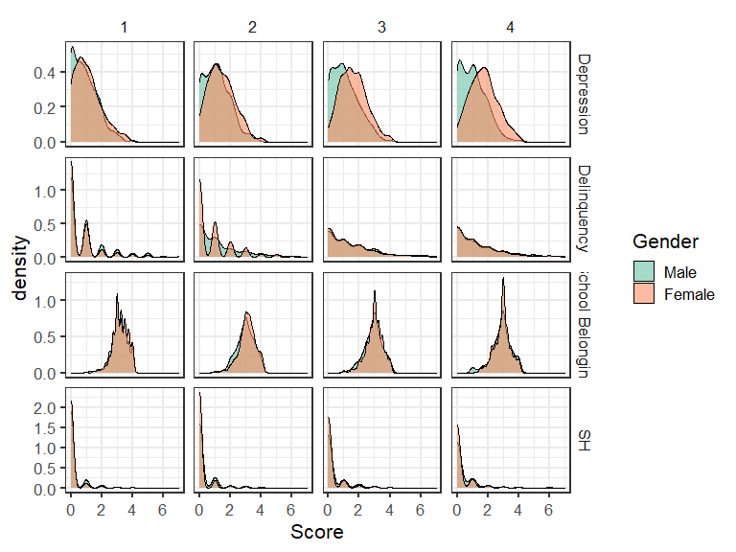

**Model Fit**

| outcome | model | ntotal | npar | χ2 | df | pvalue | cfi | rmsea | rmsea.ci | srmr | Δχ2 | Δdf | Δp | Δcfi | Δrmsea | Δsrmr |
| --- | --- | --- | --- | --- | --- | --- | --- | --- | --- | --- | --- | --- | --- | --- | --- | --- |
| Delinquency | Free | 1,556.00 | 18.00 | 93.26 | 10.00 | 0.00 | 0.92 | 0.10 | [0.09, 0.12] | 0.06 |  |  |  |  |  |  |
| Delinquency | Equal | 1,556.00 | 9.00 | 126.82 | 19.00 | 0.00 | 0.90 | 0.09 | [0.07, 0.10] | 0.11 | 44.84 | 9.00 | 0.00 | -0.02 | -0.02 | 0.05 |
| Depression | Free | 1,557.00 | 18.00 | 81.50 | 10.00 | 0.00 | 0.93 | 0.10 | [0.08, 0.12] | 0.05 |  |  |  |  |  |  |
| Depression | Equal | 1,557.00 | 9.00 | 236.31 | 19.00 | 0.00 | 0.78 | 0.12 | [0.11, 0.14] | 0.15 | 154.93 | 9.00 | 0.00 | -0.15 | 0.02 | 0.10 |
| Sexual Harassment | Free | 1,557.00 | 18.00 | 6.27 | 10.00 | 0.79 | 1.00 | 0.00 | [0.00, 0.03] | 0.03 |  |  |  |  |  |  |
| Sexual Harassment | Equal | 1,557.00 | 9.00 | 36.33 | 19.00 | 0.01 | 0.88 | 0.03 | [0.02, 0.05] | 0.14 | 23.67 | 9.00 | 0.00 | -0.12 | 0.03 | 0.10 |

**Freely Estimated Growth Parameters**

| outcome | Group | Means_I | Means_S | Variances_I | Variances_S | S.WITH_I |
| --- | --- | --- | --- | --- | --- | --- |
| Delinquency | Female | 0.71 (0.09)* | 0.31 (0.04)* | 0.88 (0.16)* | 0.24 (0.06)* | -0.06 (0.05) |
| Delinquency | Male | 1.05 (0.07)* | 0.23 (0.06)* | 0.97 (0.22)* | 0.26 (0.06)* | -0.01 (0.09) |
| Depression | Female | 1.20 (0.06)* | 0.24 (0.02)* | 0.40 (0.06)* | 0.06 (0.01)* | -0.04 (0.02)* |
| Depression | Male | 1.01 (0.05)* | 0.04 (0.02)* | 0.37 (0.04)* | 0.05 (0.02)* | -0.04 (0.02) |
| Sexual Harassment | Female | 0.17 (0.02)* | 0.07 (0.02)* | 0.17 (0.05)* | 0.05 (0.02)* | -0.02 (0.03) |
| Sexual Harassment | Male | 0.28 (0.04)* | 0.08 (0.03)* | 0.24 (0.06)* | 0.05 (0.04) | -0.01 (0.04) |

*Note.* Cluster robust standard errors are in the parentheses (). \**p* < .05

**Growth Curve Across 4 Waves**

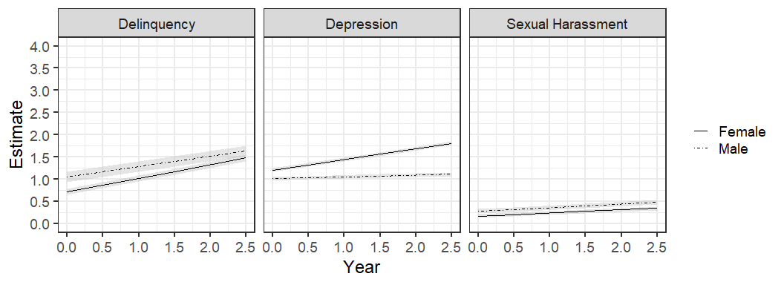

### 

### Race

**Score Distribution by Wave**

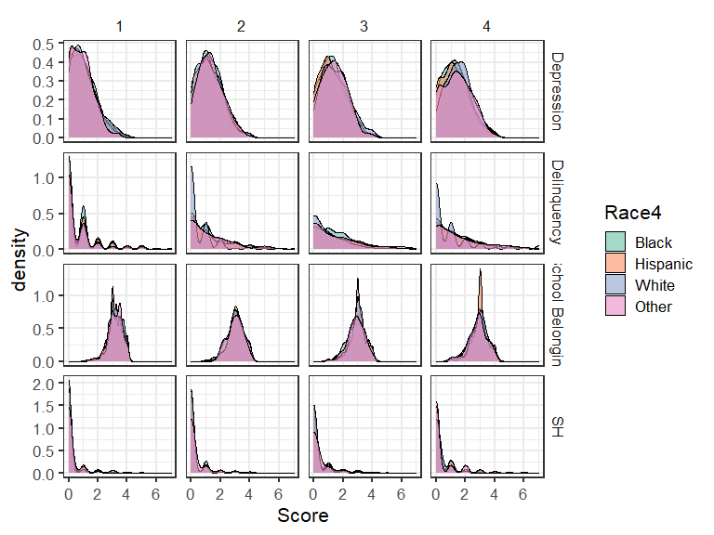

**Model Fit**

| outcome | model | ntotal | npar | χ2 | df | pvalue | cfi | rmsea | rmsea.ci | srmr | Δχ2 | Δdf | Δp | Δcfi | Δrmsea | Δsrmr |
| --- | --- | --- | --- | --- | --- | --- | --- | --- | --- | --- | --- | --- | --- | --- | --- | --- |
| Delinquency | Free | 1,562.00 | 36.00 | 113.89 | 20.00 | 0.00 | 0.87 | 0.11 | [0.09, 0.13] | 0.07 |  |  |  |  |  |  |
| Delinquency | Equal | 1,562.00 | 9.00 | 163.87 | 47.00 | 0.00 | 0.84 | 0.08 | [0.07, 0.09] | 0.14 | 64.73 | 27.00 | 0.00 | -0.03 | -0.03 | 0.07 |
| Depression | Free | 1,563.00 | 36.00 | 90.56 | 20.00 | 0.00 | 0.94 | 0.10 | [0.08, 0.12] | 0.05 |  |  |  |  |  |  |
| Depression | Equal | 1,563.00 | 9.00 | 142.22 | 47.00 | 0.00 | 0.92 | 0.07 | [0.06, 0.09] | 0.09 | 47.08 | 27.00 | 0.01 | -0.02 | -0.02 | 0.03 |
| Sexual Harassment | Free | 1,563.00 | 36.00 | 21.54 | 20.00 | 0.37 | 0.99 | 0.01 | [0.00, 0.05] | 0.06 |  |  |  |  |  |  |
| Sexual Harassment | Equal | 1,563.00 | 9.00 | 64.66 | 47.00 | 0.04 | 0.91 | 0.03 | [0.00, 0.05] | 0.14 | 40.29 | 27.00 | 0.05 | -0.08 | 0.02 | 0.08 |

**Freely Estimated Growth Parameters**

| Outcome | group | Int | Slope | Int_Int | Slope_Slope | Int_Slope |
| --- | --- | --- | --- | --- | --- | --- |
| Delinquency | Black | 1.03 (0.09)* | 0.22 (0.05)* | 0.83 (0.15)* | 0.14 (0.06)* | -0.02 (0.07) |
| Delinquency | Hispanic | 0.91 (0.13)* | 0.28 (0.05)* | 0.96 (0.30)* | 0.25 (0.08)* | -0.02 (0.09) |
| Delinquency | Other | 0.93 (0.09)* | 0.29 (0.10)* | 1.39 (0.30)* | 0.39 (0.10)* | -0.28 (0.15) |
| Delinquency | White | 0.55 (0.08)* | 0.30 (0.04)* | 0.70 (0.16)* | 0.40 (0.07)* | -0.03 (0.08) |
| Depression | Black | 1.14 (0.05)* | 0.09 (0.02)* | 0.33 (0.06)* | 0.02 (0.01) | -0.01 (0.03) |
| Depression | Hispanic | 1.09 (0.10)* | 0.13 (0.03)* | 0.43 (0.08)* | 0.07 (0.01)* | -0.03 (0.01)* |
| Depression | Other | 1.03 (0.09)* | 0.22 (0.04)* | 0.35 (0.05)* | 0.12 (0.04)* | -0.08 (0.03)* |
| Depression | White | 1.12 (0.06)* | 0.19 (0.03)* | 0.44 (0.06)* | 0.08 (0.02)* | -0.05 (0.03) |
| Sexual_Harassment | Black | 0.25 (0.04)* | 0.09 (0.04)* | 0.21 (0.06)* | 0.05 (0.05) | -0.03 (0.04) |
| Sexual_Harassment | Hispanic | 0.23 (0.05)* | 0.04 (0.03) | 0.21 (0.09)* | 0.06 (0.03) | -0.03 (0.04) |
| Sexual_Harassment | Other | 0.27 (0.04)* | 0.13 (0.03)* | 0.14 (0.09) | -0.01 (0.05) | 0.08 (0.04) |
| Sexual_Harassment | White | 0.16 (0.03)* | 0.06 (0.02)* | 0.26 (0.12)* | 0.05 (0.04) | -0.02 (0.06) |

*Note.* Cluster robust standard errors are in the parentheses (). \**p* < .05

**Growth Curve Across 4 Waves**

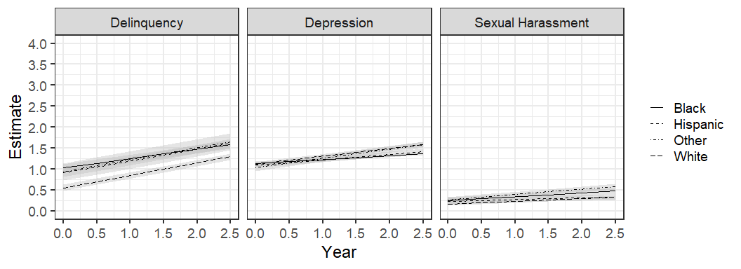

### 

### School Belonging

**Score Distribution by Wave**

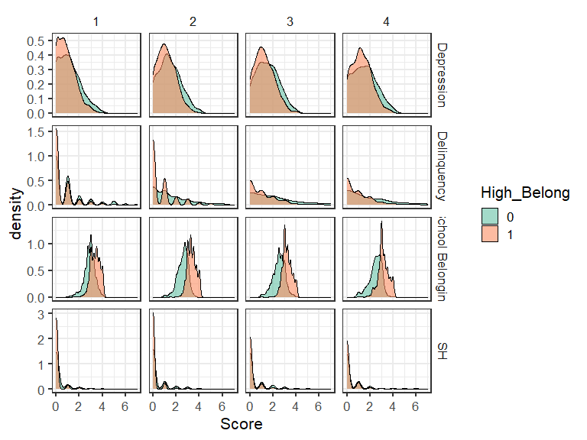

**Model Fit**

| outcome | model | ntotal | npar | χ2 | df | pvalue | cfi | rmsea | rmsea.ci | srmr | Δχ2 | Δdf | Δp | Δcfi | Δrmsea | Δsrmr |
| --- | --- | --- | --- | --- | --- | --- | --- | --- | --- | --- | --- | --- | --- | --- | --- | --- |
| Delinquency | Free | 1,560.00 | 18.00 | 74.52 | 10.00 | 0.00 | 0.92 | 0.09 | [0.07, 0.11] | 0.06 |  |  |  |  |  |  |
| Delinquency | Equal | 1,560.00 | 9.00 | 339.87 | 19.00 | 0.00 | 0.59 | 0.15 | [0.13, 0.16] | 0.22 | 294.75 | 9.00 | 0.00 | -0.33 | 0.06 | 0.16 |
| Depression | Free | 1,561.00 | 18.00 | 66.83 | 10.00 | 0.00 | 0.94 | 0.09 | [0.07, 0.10] | 0.05 |  |  |  |  |  |  |
| Depression | Equal | 1,561.00 | 9.00 | 156.15 | 19.00 | 0.00 | 0.86 | 0.10 | [0.08, 0.11] | 0.11 | 91.72 | 9.00 | 0.00 | -0.08 | 0.01 | 0.07 |
| Sexual Harassment | Free | 1,561.00 | 16.00 | 19.98 | 12.00 | 0.07 | 0.95 | 0.03 | [0.00, 0.05] | 0.05 |  |  |  |  |  |  |
| Sexual Harassment | Equal | 1,561.00 | 9.00 | 208.79 | 19.00 | 0.00 | 0.00 | 0.11 | [0.10, 0.13] | 0.36 | 117.12 | 7.00 | 0.00 | -0.95 | 0.08 | 0.31 |

**Freely Estimated Growth Parameters**

| outcome | Group | Means_I | Means_S | Variances_I | Variances_S | S.WITH_I |
| --- | --- | --- | --- | --- | --- | --- |
| Delinquency | High | 0.63 (0.06)* | 0.23 (0.04)* | 0.63 (0.09)* | 0.18 (0.04)* | -0.03 (0.03) |
| Delinquency | Moderate | 1.25 (0.10)* | 0.33 (0.05)* | 1.17 (0.26)* | 0.36 (0.07)* | -0.10 (0.09) |
| Depression | High | 1.01 (0.05)* | 0.14 (0.02)* | 0.30 (0.03)* | 0.06 (0.01)* | -0.03 (0.01)* |
| Depression | Moderate | 1.25 (0.07)* | 0.14 (0.03)* | 0.49 (0.08)* | 0.07 (0.02)* | -0.04 (0.03) |
| Sexual Harassment | High | 0.14 (0.02)* | 0.06 (0.01)* | 0.10 (0.02)* | 0.00 (0.00) | 0.00 (0.00) |
| Sexual Harassment | Moderate | 0.37 (0.04)* | 0.10 (0.03)* | 0.32 (0.08)* | 0.14 (0.05)* | -0.03 (0.05) |

*Note.* Cluster robust standard errors are in the parentheses (). \**p* < .05

**Growth Curve Across 4 Waves**

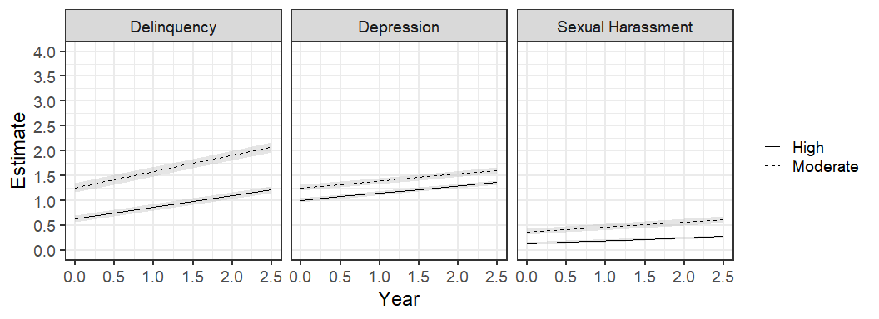

## 

## Wave 1 Predictors

### Gender

*With Interactions*

**Model Fit**

| Group | Outcome | ntotal | npar | chisq | df | pvalue | cfi | rmsea | rmsea.ci | srmr |
| --- | --- | --- | --- | --- | --- | --- | --- | --- | --- | --- |
| Female | Delinquency | 761.00 | 174.00 | 82.97 | 35.00 | 0.00 | 0.94 | 0.04 | [0.03, 0.05] | 0.02 |
| Female | Depression | 761.00 | 174.00 | 80.95 | 35.00 | 0.00 | 0.94 | 0.04 | [0.03, 0.05] | 0.02 |
| Female | Sexual Harassment | 761.00 | 174.00 | 35.40 | 35.00 | 0.45 | 1.00 | 0.00 | [0.00, 0.03] | 0.01 |
| Male | Delinquency | 797.00 | 174.00 | 91.01 | 35.00 | 0.00 | 0.91 | 0.04 | [0.03, 0.06] | 0.02 |
| Male | Depression | 797.00 | 174.00 | 82.46 | 35.00 | 0.00 | 0.93 | 0.04 | [0.03, 0.05] | 0.02 |
| Male | Sexual Harassment | 797.00 | 174.00 | 36.02 | 35.00 | 0.42 | 1.00 | 0.01 | [0.00, 0.03] | 0.02 |

**Standardized Estimates**

| predictor | Sexual Harassment | | | | Delinquency | | | | Depression | | | |
| --- | --- | --- | --- | --- | --- | --- | --- | --- | --- | --- | --- | --- |
| Female | | Male | | Female | | Male | | Female | | Male | |
| I | S | I | S | I | S | I | S | I | S | I | S |
| Intercept term | -0.23 (0.32) | 0.21 (0.40) | 0.60 (0.17)** | 0.41 (0.42) | 0.31 (0.13)* | 0.57 (0.36) | 1.58 (0.22)** | 0.26 (0.25) | 2.10 (0.25)** | 1.33 (0.47)** | 2.47 (0.16)** | -0.53 (0.39) |
| Family Conflict (FC) | 0.27 (0.18) | 0.80 (0.51) | 0.20 (0.19) | 0.22 (0.34) | 0.71 (0.18)** | 0.83 (0.22)** | 0.33 (0.15)* | -0.14 (0.18) | 1.08 (0.18)** | -0.70 (0.34)* | 0.16 (0.17) | -0.13 (0.28) |
| Abuse | 0.96 (0.34)** | -1.54 (0.40)** | 0.11 (0.34) | -0.07 (0.42) | 0.21 (0.20) | -0.65 (0.42) | 0.09 (0.24) | 0.16 (0.22) | -0.01 (0.23) | 0.10 (0.39) | -0.21 (0.18) | 0.72 (0.25)** |
| Sibling Aggression (SA) | 0.31 (0.13)* | 0.28 (0.45) | 0.01 (0.09) | -0.57 (0.29)* | 0.02 (0.15) | -0.20 (0.16) | 0.26 (0.16) | -0.41 (0.39) | -0.15 (0.13) | 0.13 (0.15) | 0.25 (0.21) | 0.01 (0.12) |
| Lack of Empathy | 0.08 (0.06) | 0.00 (0.06) | -0.04 (0.04) | 0.04 (0.08) | 0.09 (0.03)** | 0.06 (0.03) | 0.05 (0.04) | 0.03 (0.04) | -0.13 (0.05)** | -0.04 (0.06) | -0.15 (0.05)** | 0.00 (0.09) |
| Black | -0.09 (0.05) | 0.19 (0.10) | 0.02 (0.05) | 0.00 (0.12) | 0.02 (0.06) | -0.04 (0.07) | -0.03 (0.05) | -0.07 (0.06) | -0.09 (0.06) | -0.06 (0.07) | -0.01 (0.05) | 0.00 (0.05) |
| White | -0.06 (0.07) | 0.02 (0.07) | -0.06 (0.04) | 0.05 (0.07) | -0.14 (0.04)** | -0.01 (0.05) | -0.11 (0.04)* | 0.04 (0.05) | -0.09 (0.06) | 0.06 (0.07) | 0.00 (0.06) | 0.17 (0.07)** |
| Other Race | -0.01 (0.05) | 0.18 (0.10) | -0.02 (0.05) | 0.10 (0.11) | -0.06 (0.05) | 0.17 (0.09) | 0.06 (0.03) | -0.15 (0.08)* | -0.09 (0.04)* | 0.20 (0.07)** | -0.02 (0.05) | -0.01 (0.06) |
| High School Belonging (HSB) | -0.05 (0.05) | -0.22 (0.10)* | -0.05 (0.09) | -0.09 (0.10) | -0.04 (0.04) | -0.15 (0.06)* | -0.10 (0.08) | -0.15 (0.09) | -0.21 (0.05)** | -0.16 (0.07)* | -0.12 (0.06)* | 0.00 (0.10) |
| Academic Grades | 0.08 (0.07) | 0.09 (0.14) | -0.03 (0.06) | -0.02 (0.08) | -0.03 (0.05) | 0.03 (0.06) | -0.26 (0.04)** | 0.17 (0.05)** | 0.01 (0.07) | 0.04 (0.10) | -0.23 (0.04)** | 0.29 (0.08)** |
| FC x HSB | -0.09 (0.13) | 0.06 (0.18) | -0.16 (0.10) | -0.07 (0.15) | -0.28 (0.10)** | -0.06 (0.10) | -0.08 (0.10) | 0.02 (0.14) | -0.01 (0.09) | 0.09 (0.09) | 0.01 (0.09) | 0.03 (0.15) |
| Abuse x HSB | -0.14 (0.14) | 0.15 (0.13) | -0.28 (0.09)** | 0.15 (0.15) | -0.07 (0.12) | 0.28 (0.12)* | -0.04 (0.05) | -0.10 (0.17) | 0.00 (0.07) | 0.00 (0.11) | 0.11 (0.08) | -0.04 (0.06) |
| SA x HSB | 0.01 (0.07) | -0.07 (0.14) | -0.04 (0.12) | 0.16 (0.18) | 0.11 (0.04)** | -0.01 (0.09) | -0.17 (0.09) | 0.15 (0.11) | 0.00 (0.09) | 0.11 (0.12) | -0.01 (0.04) | -0.25 (0.16) |
| FC x AG | -0.07 (0.17) | -0.82 (0.52) | -0.01 (0.22) | -0.16 (0.30) | -0.23 (0.20) | -0.84 (0.21)** | -0.11 (0.13) | 0.00 (0.23) | -0.66 (0.23)** | 0.43 (0.31) | 0.26 (0.15) | -0.14 (0.24) |
| Abuse x AG | -0.53 (0.31) | 1.22 (0.38)** | 0.36 (0.43) | -0.22 (0.38) | 0.18 (0.20) | 0.25 (0.35) | 0.09 (0.21) | -0.16 (0.30) | 0.09 (0.20) | -0.12 (0.32) | 0.17 (0.19) | -0.71 (0.25)** |
| SA x AG | -0.33 (0.14)* | -0.20 (0.35) | 0.11 (0.16) | 0.48 (0.28) | -0.19 (0.13) | 0.33 (0.16)* | -0.07 (0.16) | 0.22 (0.36) | 0.24 (0.14) | -0.17 (0.19) | -0.04 (0.20) | 0.06 (0.25) |

*\*p*  < .05, \*\**p* < .01

**Table X**

*Standardized Estimates (Standard Errors) from Latent Growth Model of Sexual Harassment Perpetration Stratified by Gender*

|  | Female | |  | Male | |
| --- | --- | --- | --- | --- | --- |
| Intercept | Slope |  | Intercept | Slope |
| Intercept term | -0.23 (0.32) | 0.21 (0.40) |  | 0.60 (0.17)** | 0.41 (0.42) |
| Family Conflict (FC) | 0.27 (0.18) | 0.80 (0.51) |  | 0.20 (0.19) | 0.22 (0.34) |
| Abuse | 0.96 (0.34)** | -1.54 (0.40)** |  | 0.11 (0.34) | -0.07 (0.42) |
| Sibling Aggression (SA) | 0.31 (0.13)* | 0.28 (0.45) |  | 0.01 (0.09) | -0.57 (0.29)* |
| Lack of Empathy | 0.08 (0.06) | 0.00 (0.06) |  | -0.04 (0.04) | 0.04 (0.08) |
| Black | -0.09 (0.05) | 0.19 (0.10) |  | 0.02 (0.05) | 0.00 (0.12) |
| White | -0.06 (0.07) | 0.02 (0.07) |  | -0.06 (0.04) | 0.05 (0.07) |
| Other Race | -0.01 (0.05) | 0.18 (0.10) |  | -0.02 (0.05) | 0.10 (0.11) |
| High School Belonging (HSB) | -0.05 (0.05) | -0.22 (0.10)* |  | -0.05 (0.09) | -0.09 (0.10) |
| Academic Grades | 0.08 (0.07) | 0.09 (0.14) |  | -0.03 (0.06) | -0.02 (0.08) |
| FC x HSB | -0.09 (0.13) | 0.06 (0.18) |  | -0.16 (0.10) | -0.07 (0.15) |
| Abuse x HSB | -0.14 (0.14) | 0.15 (0.13) |  | -0.28 (0.09)** | 0.15 (0.15) |
| SA x HSB | 0.01 (0.07) | -0.07 (0.14) |  | -0.04 (0.12) | 0.16 (0.18) |
| FC x AG | -0.07 (0.17) | -0.82 (0.52) |  | -0.01 (0.22) | -0.16 (0.30) |
| Abuse x AG | -0.53 (0.31) | 1.22 (0.38)** |  | 0.36 (0.43) | -0.22 (0.38) |
| SA x AG | -0.33 (0.14)* | -0.20 (0.35) |  | 0.11 (0.16) | 0.48 (0.28) |

*\*p*  < .05, \**p* < .01

### Race

*With Interactions*

**Model Fit**

| Group | Outcome | ntotal | npar | chisq | df | pvalue | cfi | rmsea | rmsea.ci | srmr |
| --- | --- | --- | --- | --- | --- | --- | --- | --- | --- | --- |
| Black | Delinquency | 460.00 | 139.00 | 53.17 | 31.00 | 0.01 | 0.94 | 0.04 | [0.02, 0.06] | 0.03 |
| Black | Depression | 460.00 | 139.00 | 66.14 | 31.00 | 0.00 | 0.90 | 0.05 | [0.03, 0.07] | 0.03 |
| Black | Sexual Harassment | 460.00 | 139.00 | 37.36 | 31.00 | 0.20 | 0.96 | 0.02 | [0.00, 0.04] | 0.02 |
| White | Delinquency | 298.00 | 139.00 | 44.39 | 31.00 | 0.06 | 0.95 | 0.04 | [0.00, 0.06] | 0.03 |
| White | Depression | 298.00 | 139.00 | 32.64 | 31.00 | 0.39 | 1.00 | 0.01 | [0.00, 0.05] | 0.02 |
| White | Sexual Harassment | 298.00 | 94.00 | 30.25 | 25.00 | 0.22 | 0.96 | 0.03 | [0.00, 0.06] | 0.03 |
| Hispanic | Delinquency | 605.00 | 139.00 | 94.39 | 31.00 | 0.00 | 0.90 | 0.06 | [0.04, 0.07] | 0.03 |
| Hispanic | Depression | 605.00 | 139.00 | 97.53 | 31.00 | 0.00 | 0.94 | 0.06 | [0.05, 0.07] | 0.03 |
| Hispanic | Sexual Harassment | 605.00 | 139.00 | 40.92 | 31.00 | 0.11 | 0.97 | 0.02 | [0.00, 0.04] | 0.02 |

White with ACEs by Academic Grades interactions:

|  |  |  |  |  |  |  |  |  |  |  |
| --- | --- | --- | --- | --- | --- | --- | --- | --- | --- | --- |
| White | Sexual Harassment | 298.00 | 139.00 | 100.77 | 31.00 | 0.00 | 0.62 | 0.09 | [0.07, 0.11] | 0.03 |

**Standardized Estimates**

| predictor | Sexual Harassment | | | | | | Delinquency | | | | | | Depression | | | | | |
| --- | --- | --- | --- | --- | --- | --- | --- | --- | --- | --- | --- | --- | --- | --- | --- | --- | --- | --- |
| Black | | White | | Hispanic | | Black | | White | | Hispanic | | Black | | White | | Hispanic | |
| I | S | I | S | I | S | I | S | I | S | I | S | I | S | I | S | I | S |
| Intercept term | 0.26 (0.41) | 0.05 (0.52) | 0.22 (0.36) | 0.88 (0.54) | 0.48 (0.24)* | 0.60 (0.33) | 1.36 (0.38)** | -0.64 (0.69) | 0.77 (0.34)* | 1.00 (0.58) | 1.19 (0.25)** | 0.46 (0.40) | 2.29 (0.27)** | -1.28 (0.57)* | 1.40 (0.44)** | 1.87 (1.12) | 2.14 (0.18)** | -0.34 (0.46) |
| Family Conflict (FC) | 0.39 (0.12)** | 0.60 (0.28)* | -0.08 (0.10) | 0.17 (0.17) | 0.09 (0.34) | 0.19 (0.47) | 0.42 (0.20)* | 0.41 (0.38) | 0.64 (0.38) | 0.06 (0.65) | 0.46 (0.12)** | -0.02 (0.18) | 0.32 (0.21) | 0.14 (0.40) | 1.10 (0.44)* | -0.54 (0.71) | 0.49 (0.13)** | -0.45 (0.07)** |
| Abuse | -0.06 (0.27) | -0.54 (0.22)* | 0.12 (0.20) | -0.53 (0.22)* | 0.72 (0.40) | -0.93 (0.40)* | -0.12 (0.28) | 0.35 (0.49) | -0.38 (0.88) | 0.92 (0.76) | 0.57 (0.36) | -0.52 (0.37) | -0.15 (0.24) | 0.68 (0.48) | -0.23 (0.34) | 0.70 (0.69) | -0.08 (0.20) | 0.56 (0.16)** |
| Sibling Aggression (SA) | -0.14 (0.15) | 0.73 (0.37)* | 0.21 (0.09)* | 0.11 (0.11) | -0.04 (0.10) | -0.34 (0.24) | -0.03 (0.14) | 0.27 (0.21) | -0.04 (0.91) | -1.53 (0.60)* | -0.04 (0.22) | -0.22 (0.43) | -0.17 (0.12) | 0.50 (0.31) | 0.42 (0.64) | -1.45 (0.81) | 0.08 (0.11) | 0.22 (0.13) |
| Lack of Empathy | 0.05 (0.06) | -0.02 (0.07) | 0.07 (0.07) | 0.03 (0.16) | -0.01 (0.05) | 0.02 (0.04) | 0.05 (0.05) | 0.13 (0.12) | 0.11 (0.07) | 0.01 (0.08) | 0.07 (0.05) | 0.03 (0.07) | -0.12 (0.04)** | 0.05 (0.09) | -0.11 (0.08) | -0.23 (0.10)* | -0.16 (0.06)* | 0.05 (0.10) |
| Female | -0.15 (0.07)* | 0.09 (0.10) | -0.08 (0.08) | -0.10 (0.10) | -0.07 (0.05) | -0.10 (0.06) | -0.06 (0.06) | 0.09 (0.11) | -0.15 (0.07)* | -0.04 (0.04) | -0.12 (0.04)** | 0.00 (0.10) | 0.16 (0.04)** | 0.52 (0.13)** | 0.07 (0.04) | 0.30 (0.08)** | 0.16 (0.07)* | 0.37 (0.03)** |
| High School Belonging (HSB) | -0.02 (0.10) | -0.09 (0.08) | -0.20 (0.06)** | 0.00 (0.14) | -0.01 (0.07) | -0.12 (0.09) | -0.05 (0.05) | -0.06 (0.13) | -0.14 (0.08) | -0.20 (0.13) | -0.01 (0.04) | -0.16 (0.05)** | -0.16 (0.07)* | 0.10 (0.14) | -0.25 (0.13)* | -0.10 (0.16) | -0.09 (0.04)* | -0.11 (0.11) |
| Academic Grades | 0.00 (0.10) | 0.13 (0.13) | 0.03 (0.07) | -0.14 (0.20) | -0.06 (0.02)** | -0.03 (0.06) | -0.21 (0.08)** | 0.32 (0.13)* | -0.10 (0.05)* | -0.03 (0.11) | -0.25 (0.04)** | 0.10 (0.08) | -0.15 (0.09) | 0.40 (0.19)* | 0.06 (0.09) | -0.15 (0.19) | -0.18 (0.05)** | 0.21 (0.05)** |
| FC x HSB | -0.25 (0.12)* | -0.01 (0.15) | 0.17 (0.10) | -0.05 (0.18) | -0.13 (0.17) | -0.09 (0.23) | -0.27 (0.10)* | -0.18 (0.13) | -0.15 (0.16) | 0.28 (0.19) | -0.20 (0.10)* | -0.18 (0.09) | -0.08 (0.14) | 0.06 (0.24) | 0.22 (0.18) | -0.43 (0.20)* | -0.09 (0.08) | 0.15 (0.11) |
| Abuse x HSB | -0.13 (0.19) | 0.12 (0.17) | 0.14 (0.26) | 0.20 (0.23) | -0.31 (0.16)* | 0.16 (0.23) | -0.05 (0.10) | 0.04 (0.14) | 0.18 (0.11) | -0.05 (0.22) | -0.18 (0.09)* | 0.13 (0.17) | -0.04 (0.13) | 0.02 (0.18) | 0.13 (0.13) | 0.07 (0.17) | 0.08 (0.05) | -0.11 (0.06) |
| SA x HSB | 0.05 (0.09) | 0.08 (0.14) | -0.28 (0.10)** | -0.07 (0.22) | 0.07 (0.09) | 0.12 (0.19) | 0.03 (0.07) | 0.20 (0.10)* | -0.13 (0.07) | -0.10 (0.17) | 0.01 (0.10) | 0.27 (0.23) | 0.27 (0.09)** | -0.09 (0.27) | -0.02 (0.07) | 0.33 (0.09)** | -0.14 (0.09) | -0.17 (0.10) |
| FC x AG | -0.04 (0.16) | -0.58 (0.26)* |  |  | 0.11 (0.18) | -0.07 (0.22) | 0.01 (0.23) | -0.26 (0.40) | -0.28 (0.35) | -0.41 (0.59) | -0.11 (0.17) | 0.22 (0.19) | 0.15 (0.23) | -0.35 (0.43) | -0.85 (0.41)* | 0.60 (0.71) | 0.00 (0.07) | 0.11 (0.14) |
| Abuse x AG | 0.34 (0.23) | 0.40 (0.26) |  |  | -0.08 (0.32) | 0.49 (0.23)* | 0.42 (0.29) | -0.66 (0.47) | 0.41 (0.88) | -1.00 (0.84) | -0.10 (0.39) | 0.23 (0.48) | 0.28 (0.17) | -0.67 (0.50) | 0.18 (0.31) | -0.82 (0.63) | 0.07 (0.20) | -0.53 (0.13)** |
| SA x AG | 0.20 (0.18) | -0.94 (0.46)* |  |  | -0.01 (0.09) | 0.28 (0.26) | -0.05 (0.16) | -0.61 (0.28)* | 0.06 (0.93) | 1.69 (0.66)* | 0.07 (0.15) | 0.00 (0.33) | 0.11 (0.20) | -0.56 (0.52) | -0.26 (0.67) | 1.12 (0.77) | 0.15 (0.13) | -0.01 (0.21) |

**Table X**

*Standardized Estimates (Standard Errors) from Latent Growth Model of Sexual Harassment Perpetration Stratified by Race*

|  | Black | |  | White | |  | Hispanic | |
| --- | --- | --- | --- | --- | --- | --- | --- | --- |
| Intercept | Slope |  | Intercept | Slope |  | Intercept | Slope |
| Intercept term | 0.26 (0.41) | 0.05 (0.52) |  | 0.22 (0.36) | 0.88 (0.54) |  | 0.48 (0.24)* | 0.60 (0.33) |
| Family Conflict (FC) | 0.39 (0.12)** | 0.60 (0.28)* |  | -0.08 (0.10) | 0.17 (0.17) |  | 0.09 (0.34) | 0.19 (0.47) |
| Abuse | -0.06 (0.27) | -0.54 (0.22)* |  | 0.12 (0.20) | -0.53 (0.22)* |  | 0.72 (0.40) | -0.93 (0.40)* |
| Sibling Aggression (SA) | -0.14 (0.15) | 0.73 (0.37)* |  | 0.21 (0.09)* | 0.11 (0.11) |  | -0.04 (0.10) | -0.34 (0.24) |
| Lack of Empathy | 0.05 (0.06) | -0.02 (0.07) |  | 0.07 (0.07) | 0.03 (0.16) |  | -0.01 (0.05) | 0.02 (0.04) |
| Female | -0.15 (0.07)* | 0.09 (0.10) |  | -0.08 (0.08) | -0.10 (0.10) |  | -0.07 (0.05) | -0.10 (0.06) |
| High School Belonging (HSB) | -0.02 (0.10) | -0.09 (0.08) |  | -0.20 (0.06)** | 0.00 (0.14) |  | -0.01 (0.07) | -0.12 (0.09) |
| Academic Grades | 0.00 (0.10) | 0.13 (0.13) |  | 0.03 (0.07) | -0.14 (0.20) |  | -0.06 (0.02)** | -0.03 (0.06) |
| FC x HSB | -0.25 (0.12)* | -0.01 (0.15) |  | 0.17 (0.10) | -0.05 (0.18) |  | -0.13 (0.17) | -0.09 (0.23) |
| Abuse x HSB | -0.13 (0.19) | 0.12 (0.17) |  | 0.14 (0.26) | 0.20 (0.23) |  | -0.31 (0.16)* | 0.16 (0.23) |
| SA x HSB | 0.05 (0.09) | 0.08 (0.14) |  | -0.28 (0.10)** | -0.07 (0.22) |  | 0.07 (0.09) | 0.12 (0.19) |
| FC x AG | -0.04 (0.16) | -0.58 (0.26)* |  |  |  |  | 0.11 (0.18) | -0.07 (0.22) |
| Abuse x AG | 0.34 (0.23) | 0.40 (0.26) |  |  |  |  | -0.08 (0.32) | 0.49 (0.23)* |
| SA x AG | 0.20 (0.18) | -0.94 (0.46)* |  |  |  |  | -0.01 (0.09) | 0.28 (0.26) |

\**p* < .05, \*\**p* < .01

### School Belonging

**Model Fit**

| Belonging | Outcome | ntotal | npar | chisq | df | pvalue | cfi | rmsea | rmsea.ci | srmr |
| --- | --- | --- | --- | --- | --- | --- | --- | --- | --- | --- |
| High | Delinquency | 932.00 | 123.00 | 82.69 | 29.00 | 0.00 | 0.92 | 0.04 | [0.03, 0.06] | 0.02 |
| High | Depression | 932.00 | 123.00 | 77.27 | 29.00 | 0.00 | 0.94 | 0.04 | [0.03, 0.05] | 0.02 |
| High | Sexual Harassment | 932.00 | 121.00 | 40.71 | 31.00 | 0.11 | 0.95 | 0.02 | [0.00, 0.03] | 0.02 |
| Moderate | Delinquency | 629.00 | 123.00 | 65.68 | 29.00 | 0.00 | 0.92 | 0.04 | [0.03, 0.06] | 0.02 |
| Moderate | Depression | 629.00 | 123.00 | 71.07 | 29.00 | 0.00 | 0.94 | 0.05 | [0.03, 0.06] | 0.02 |
| Moderate | Sexual Harassment | 629.00 | 123.00 | 38.51 | 29.00 | 0.11 | 0.96 | 0.02 | [0.00, 0.04] | 0.02 |

**Standardized Estimates**

| predictor | Sexual Harassment | | | | Delinquency | | | | Depression | | | |
| --- | --- | --- | --- | --- | --- | --- | --- | --- | --- | --- | --- | --- |
| High | | Moderate | | High | | Moderate | | High | | Moderate | |
| I | S | I | S | I | S | I | S | I | S | I | S |
| Intercept term | 0.32 (0.22) | 1.38 (1.83) | 0.35 (0.35) | 0.23 (0.36) | 1.33 (0.26)** | 0.46 (0.27) | 1.04 (0.35)** | 0.04 (0.39) | 2.03 (0.33)** | -0.27 (0.30) | 2.27 (0.32)** | -0.11 (0.48) |
| Family Conflict (FC) | 0.22 (0.17) | 1.28 (1.83) | 0.19 (0.22) | 0.11 (0.28) | 0.00 (0.19) | 0.31 (0.33) | 0.62 (0.13)** | 0.05 (0.13) | 0.82 (0.30)** | -0.40 (0.19)* | 0.31 (0.14)* | -0.17 (0.32) |
| Abuse | -0.23 (0.22) | -0.41 (0.93) | 0.48 (0.29) | -0.57 (0.30) | 0.16 (0.17) | 0.00 (0.29) | 0.17 (0.19) | -0.15 (0.28) | -0.07 (0.28) | 0.08 (0.28) | -0.12 (0.14) | 0.67 (0.30)* |
| Sibling Aggression (SA) | -0.18 (0.16) | 0.10 (1.08) | 0.23 (0.18) | -0.01 (0.38) | 0.06 (0.16) | -0.17 (0.24) | 0.14 (0.15) | -0.37 (0.24) | -0.12 (0.18) | -0.07 (0.20) | 0.05 (0.13) | 0.22 (0.14) |
| Lack of Empathy | 0.03 (0.03) | 0.18 (0.21) | -0.01 (0.07) | 0.01 (0.06) | 0.06 (0.05) | 0.04 (0.05) | 0.04 (0.05) | 0.09 (0.06) | -0.12 (0.04)** | 0.03 (0.06) | -0.18 (0.06)** | -0.06 (0.10) |
| Female | -0.11 (0.05)* | -0.31 (0.37) | -0.12 (0.06)* | 0.04 (0.05) | -0.16 (0.04)** | 0.09 (0.08) | -0.12 (0.05)* | 0.09 (0.05) | 0.08 (0.03)** | 0.40 (0.05)** | 0.18 (0.05)** | 0.38 (0.05)** |
| Black | 0.00 (0.04) | 0.51 (0.38) | -0.03 (0.06) | 0.04 (0.08) | 0.05 (0.06) | -0.06 (0.07) | -0.05 (0.06) | -0.08 (0.06) | -0.04 (0.06) | 0.03 (0.06) | -0.06 (0.06) | -0.11 (0.07) |
| White | -0.06 (0.05) | 0.26 (0.26) | -0.08 (0.07) | 0.01 (0.08) | -0.12 (0.05)* | 0.02 (0.05) | -0.14 (0.05)** | -0.01 (0.07) | -0.02 (0.06) | 0.06 (0.05) | -0.07 (0.07) | 0.17 (0.09)* |
| Other Race | 0.01 (0.07) | 0.22 (0.34) | -0.01 (0.05) | 0.16 (0.09) | 0.00 (0.04) | -0.01 (0.05) | -0.04 (0.07) | 0.03 (0.12) | -0.04 (0.04) | 0.11 (0.05)* | -0.06 (0.06) | 0.03 (0.07) |
| Academic Grades | 0.00 (0.04) | -0.12 (0.28) | 0.03 (0.07) | 0.00 (0.09) | -0.20 (0.06)** | 0.01 (0.06) | -0.12 (0.07) | 0.14 (0.09) | -0.12 (0.07) | 0.12 (0.07) | -0.18 (0.06)** | 0.25 (0.11)* |
| FC x AG | -0.17 (0.18) | -1.23 (1.71) | -0.03 (0.23) | -0.12 (0.31) | 0.16 (0.19) | -0.41 (0.35) | -0.32 (0.16)* | -0.14 (0.14) | -0.37 (0.28) | 0.22 (0.18) | 0.12 (0.14) | -0.09 (0.30) |
| Abuse x AG | 0.48 (0.28) | -0.29 (1.08) | -0.12 (0.32) | 0.40 (0.30) | 0.07 (0.15) | -0.11 (0.28) | 0.09 (0.19) | -0.01 (0.25) | 0.16 (0.27) | -0.13 (0.29) | 0.14 (0.15) | -0.69 (0.25)** |
| SA x AG | 0.23 (0.19) | -0.05 (0.95) | -0.19 (0.22) | -0.01 (0.35) | -0.07 (0.15) | 0.23 (0.28) | -0.15 (0.13) | 0.38 (0.22) | 0.27 (0.16) | 0.06 (0.20) | 0.04 (0.15) | -0.25 (0.17) |

**Table X**

*Standardized Estimates (Standard Errors) from Latent Growth Model of Sexual Harassment Perpetration Stratified by School Belongingness*

|  | High | |  | Moderate | |
| --- | --- | --- | --- | --- | --- |
| Intercept | Slope |  | Intercept | Slope |
| Intercept term | 0.32 (0.22) | 1.38 (1.83) |  | 0.35 (0.35) | 0.23 (0.36) |
| Family Conflict (FC) | 0.22 (0.17) | 1.28 (1.83) |  | 0.19 (0.22) | 0.11 (0.28) |
| Abuse | -0.23 (0.22) | -0.41 (0.93) |  | 0.48 (0.29) | -0.57 (0.30) |
| Sibling Aggression (SA) | -0.18 (0.16) | 0.10 (1.08) |  | 0.23 (0.18) | -0.01 (0.38) |
| Lack of Empathy | 0.03 (0.03) | 0.18 (0.21) |  | -0.01 (0.07) | 0.01 (0.06) |
| Female | -0.11 (0.05)* | -0.31 (0.37) |  | -0.12 (0.06)* | 0.04 (0.05) |
| Black | 0.00 (0.04) | 0.51 (0.38) |  | -0.03 (0.06) | 0.04 (0.08) |
| White | -0.06 (0.05) | 0.26 (0.26) |  | -0.08 (0.07) | 0.01 (0.08) |
| Other Race | 0.01 (0.07) | 0.22 (0.34) |  | -0.01 (0.05) | 0.16 (0.09) |
| Academic Grades | 0.00 (0.04) | -0.12 (0.28) |  | 0.03 (0.07) | 0.00 (0.09) |
| FC x AG | -0.17 (0.18) | -1.23 (1.71) |  | -0.03 (0.23) | -0.12 (0.31) |
| Abuse x AG | 0.48 (0.28) | -0.29 (1.08) |  | -0.12 (0.32) | 0.40 (0.30) |
| SA x AG | 0.23 (0.19) | -0.05 (0.95) |  | -0.19 (0.22) | -0.01 (0.35) |

\**p* < .05

R-squared

| Group | I | S |
| --- | --- | --- |
| Female | 0.30 (0.10) | 0.26 (0.08) |
| Male | 0.21 (0.08) | 0.09 (0.04) |
| Hispanic | 0.36 (0.09) | 0.18 (0.14) |
| Black | 0.23 (0.08) | 0.21 (0.15) |
| White | 0.14 (0.05) | 0.18 (0.12) |
| High | 0.11 (0.07) | 1.00 (999.00) |
| Moderate | 0.24 (0.08) | 0.08 (0.05) |

# Additional Plots for Paper

**Figure 1**

*Latent Trajectories of Sexual Harassment Perpetration*

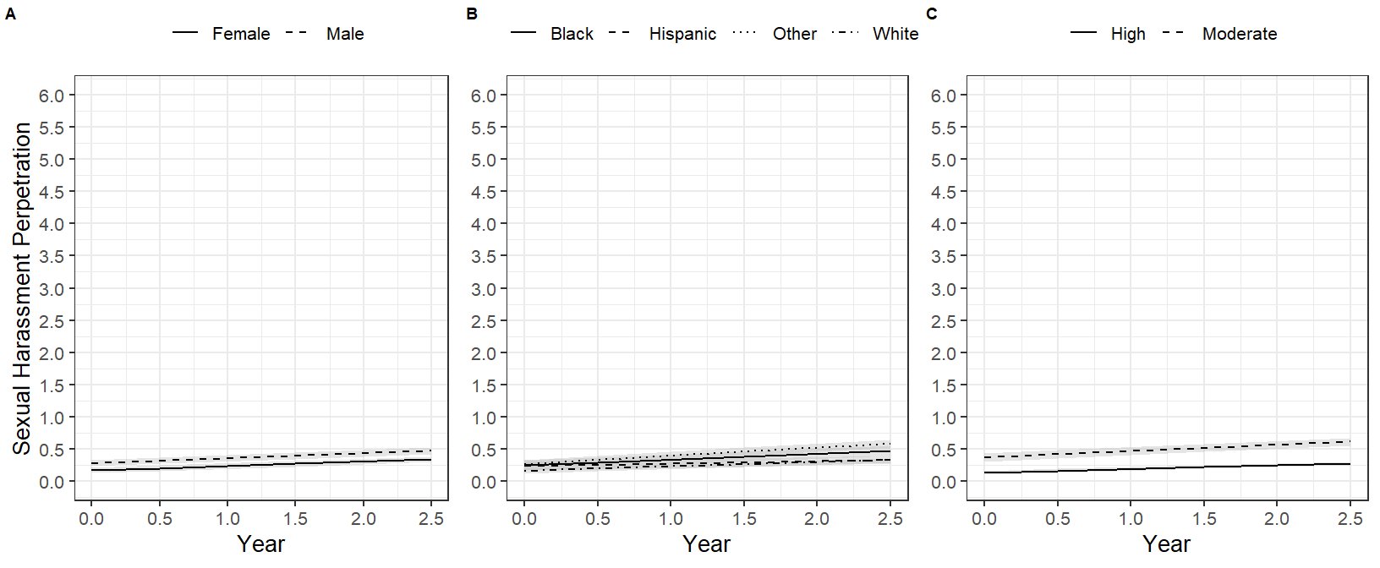

*Note*. Trajectories are freely estimated for each group in a multigroup analysis by gender (A), race (B), and school belongingness (C). Shaded are signifies 95% confidence interval around each trajectory.

**Figure 2**

*Interaction of Academic Grades and Early Hostile Home Environment on Female Adolescents’ Sexual Harassment Perpetration*

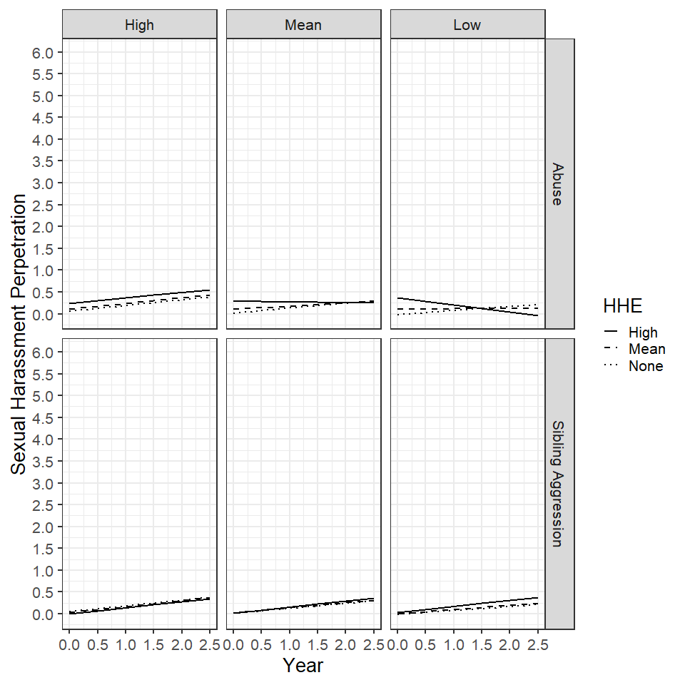

*Note.* Academic grade categories are the scale maximum (High), mean, and mean – 1 standard deviation (Low). Early hostile home environment (EHHE) categories are the mean, mean + 1 standard deviation (High), and scores of 0 (None) on the abuse or sibling aggression scales.

**Figure 3**

*Interaction of Exposure to Abuse and School Variables on Hispanic Adolescents’ Sexual Harassment Perpetration*

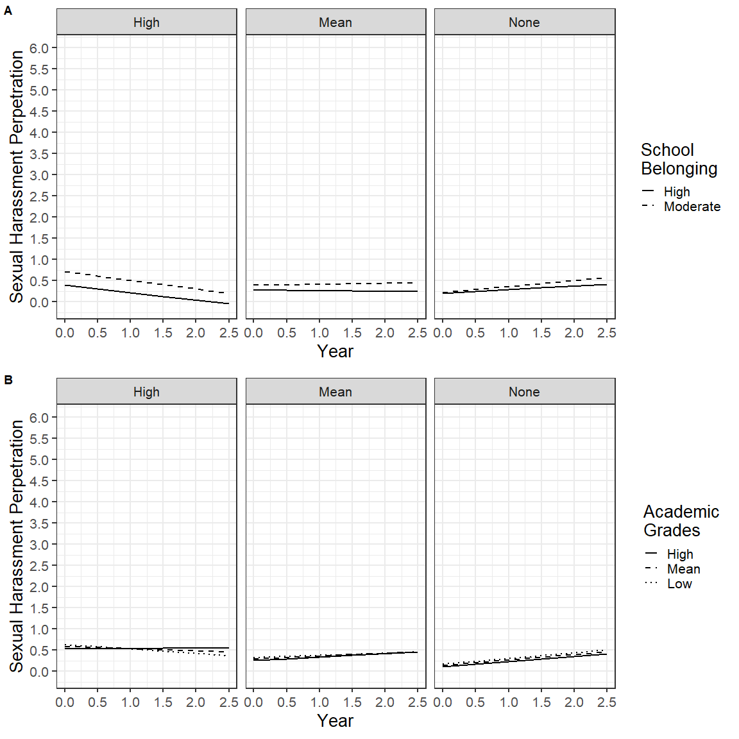

*Note.* Exposure to abuse categories were the mean, mean + 1 standard deviation (High), and scores of 0 (None) on the exposure to abuse scale. School belonging categories (A) were derived from a k-means cluster analysis and Academic grades categories (B) were the scale maximum (High), mean, and mean – 1 standard deviation (Low).

**Figure 4**

*Interaction of Academic Grades and Early Hostile Home Environment on Black Adolescents’ Sexual Harassment Perpetration*

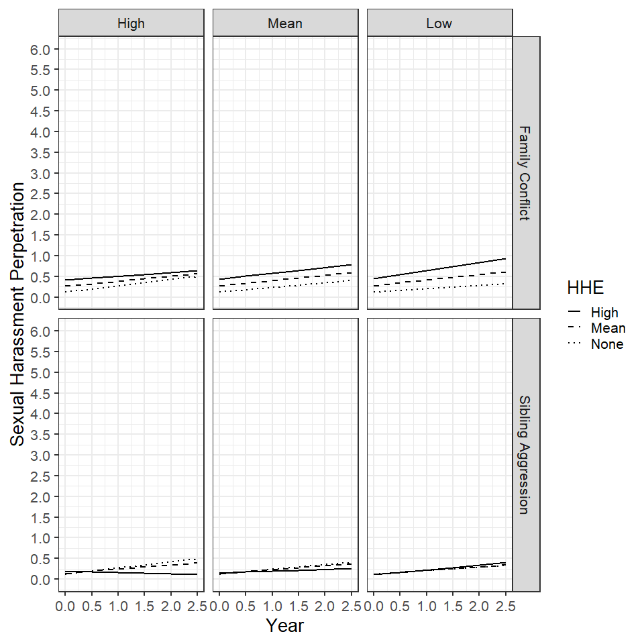

*Note.* Academic grade categories were the scale maximum (High), mean, and mean – 1 standard deviation (Low). Early hostile home environment (EHHE) categories were the mean, mean + 1 standard deviation (High), and scores of 0 (None) on the family conflict or sibling aggression scales.

**Figure 5**

*Interaction of School Belonging and Early Hostile Home Environment on Black (A), White (B), and Male (C) Adolescents’ Sexual Harassment Perpetration*

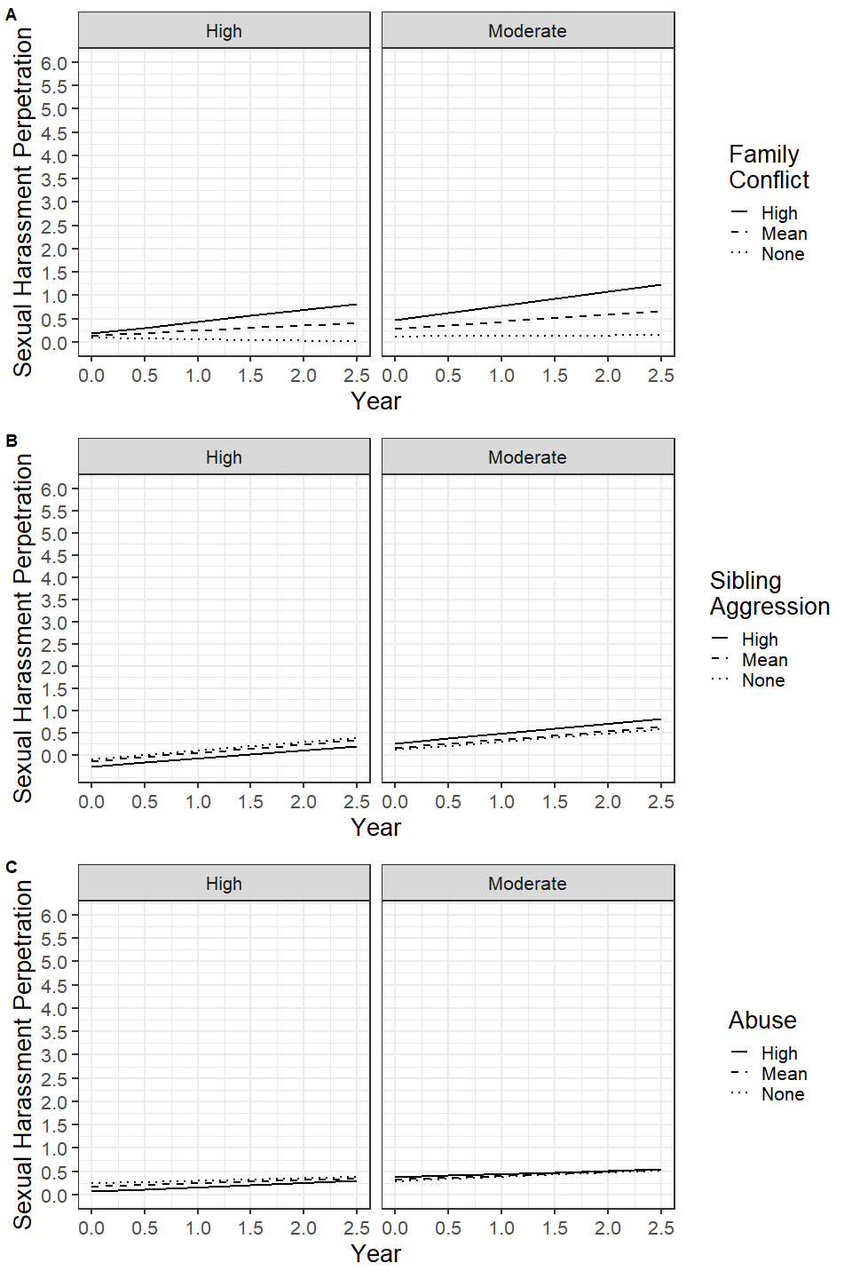

*Note.* Early hostile home environment categories were the mean, mean + 1 standard deviation (High), and scores of 0 (None) on the family conflict, sibling aggression, or exposure to abuse scales.

**Methods Text**

To ensure that the survey items measured the sexual harassment perpetration and school belongingness constructs adequately and consistently over time, a one-factor confirmatory factor analytic model was fit at each wave for each scale to assess overall model fit and identify any problematic items. Given the dichotomous or ordinal nature of the items, the models were run with a diagonally weighted least square estimator, mean and variance adjusted test statistic, and pairwise deletion (Li, 2016). Intraclass correlations of .02 and .00 for school belongingness and sexual harassment perpetration, respectively, indicated that little to no variation in the scale scores were attributable to school level variation. Nonetheless, the models adjusted for the nesting structure of students with schools with cluster robust standard errors. Across the four waves both scales demonstrated suitable fit and factor loadings (sexual harassment perpetration: *CFI* = 0.99 - 1.00, *RMSEA* = 0.00 - 0.04, *SRMR* = 0.04 - 0.09, loadings = .71 - .95; school belongingness: *CFI* = 0.99 - 1.00; *RMSEA* = 0.03 - 0.10; *SRMR* = 0.01 - 0.03, loadings = .44 - .82).

To establish longitudinal measurement invariance with ordinal items, we built on the preliminary factor analytic models by running models that sequentially imposed stricter constraints across waves (Liu et al., 2017). To identify the location and scale of the common factor (e.g., sexual harassment perpetration) at each time point, the first item’s intercept and factor loading were fixed to 0 and 1, respectively. The location and scale of each unique factor – the latent item-response underlying the ordinal responses – was identified using the theta parameterization, and the identification constraints proposed by Millsap & Tein (2004). The configural model was fit first with all parameters estimated freely across the four waves except those needed to identify the model. Next, the metric model constrained factor loadings to equality over time. The scalar model constrained factor loadings and the item thresholds. For sexual harassment perpetration, the metric and scalar models were equivalent given that all the items were dichotomous, and the only threshold was already constrained for model identification purposes. Finally, the strict model constrained the loadings, thresholds, and unique factor variances. The overall fit of the measurement invariance models was evaluated using typical guidelines of non-significant χ2 test, *CFI* > .95, *RMSEA* < .06, and *SRMR* < .08. The configural, metric, scalar, and strict models were also compared sequentially with a non-significant likelihood ratio test with the Satorra and Bentler (2001) scaled difference test statistic and change (D) in *CFI* < -0.01, *RMSEA* < 0.01, and *SRMR* < 0.01, suggesting measurement invariance (Chen, 2007; Rutkowski & Svetina, 2014). Though it should be noted that both the overall model fit and model comparison guidelines were derived with continuous indicators and maximum likelihood estimation and more research is needed on appropriate fit thresholds with ordinal items (Kline, 2015).

For the sexual harassment perpetration scale, each model (configural, metric/scalar, strict) demonstrated suitable fit to the data and the likelihood ration tests and change in fit indices suggested that constraining parameters across waves did not hinder model fit, thus providing evidence for longitudinal measurement invariance. Similarly with school belonging, each sequential model yielded suitable fit and the fit indices implied minimal change in fit as constraints were added. The likelihood ratio test between each model was significant, implying non-invariance, but the test can be overly sensitive with large sample sizes, as is the case in the present study (Kline, 2015). Thus, the preponderance of evidence supports longitudinal measurement invariance.